**ОТЧЁТ ПО ЛАБОРАТОРНОЙ РАБОТЕ № 6**

**Выполнил студент 3 курса МОиАИС**

**Сушин Андрей**

**Схема сравнения**

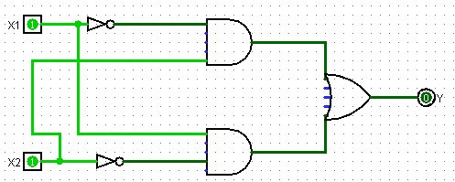

Таблица истинности

|  |  |  |
| --- | --- | --- |
| ***X1*** | ***X2*** | ***Y*** |
| 0 | 0 |  |
| 0 | 1 | 1 |
| 1 | 0 | 1 |
| 1 | 1 | 0 |

**Полусумматор**

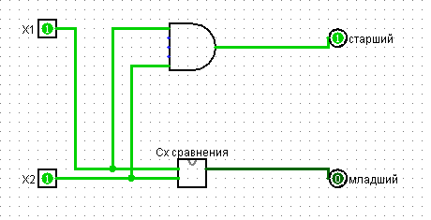

Таблица истинности

|  |  |  |  |
| --- | --- | --- | --- |
| ***X1*** | ***X2*** | **Старший Разряд Перенос** | **Младший Разряд** |
| 0 | 0 | $$0$$ | 0 |
| 0 | 1 | 0 | 1 |
| 1 | 0 | 0 | 1 |
| 1 | 1 | 1 | 0 |

**Полный сумматор**

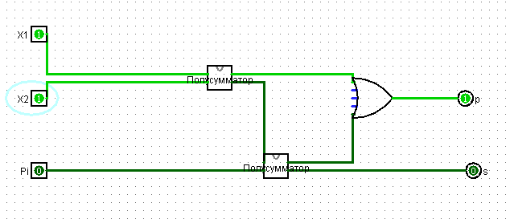

Таблица истинности

|  |  |  |  |  |
| --- | --- | --- | --- | --- |
| ***X1*** | ***X2*** | ***Pi*** | ***P*** | ***S*** |
| 0 | 0 | 0 | 0 | 0 |
| 0 | 0 | 1 | 0 | 1 |
| 0 | 1 | 0 | 0 | 1 |
| 0 | 1 | 1 | 1 | 0 |
| 1 | 0 | 0 | 0 | 1 |
| 1 | 0 | 1 | 1 | 0 |
| 1 | 1 | 0 | 1 | 0 |
| 1 | 1 | 1 | 1 | 1 |

**4 Сумматора**

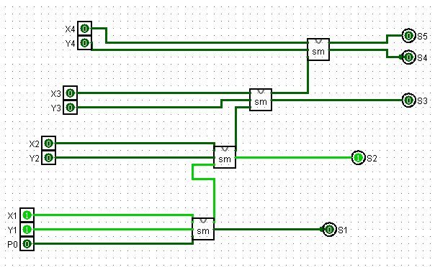

**Полусумматор (из теоретического раздела)**

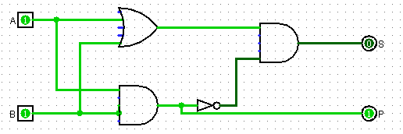

|  |  |  |  |
| --- | --- | --- | --- |
| **A** | **B** | **S** | **P** |
| 0 | 0 | 0 | 0 |
| 0 | 1 | 1 | 0 |
| 1 | 0 | 1 | 0 |
| 1 | 1 | 0 | 1 |

**Сумматор (из теоретического раздела)**

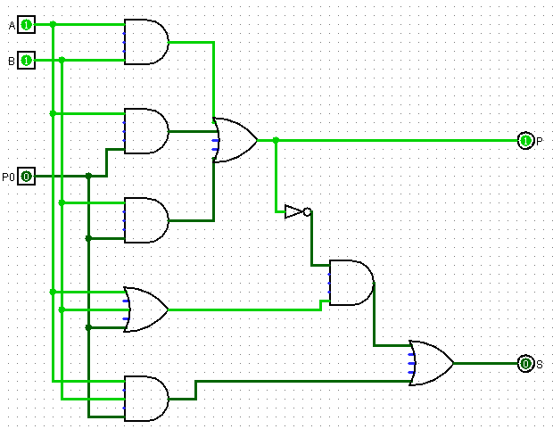

|  |  |  |  |  |
| --- | --- | --- | --- | --- |
| ***A*** | ***B*** | ***P0*** | ***P*** | ***S*** |
| 0 | 0 | 0 | 0 | 0 |
| 0 | 0 | 1 | 0 | 1 |
| 0 | 1 | 0 | 0 | 1 |
| 0 | 1 | 1 | 1 | 0 |
| 1 | 0 | 0 | 0 | 1 |
| 1 | 0 | 1 | 1 | 0 |
| 1 | 1 | 0 | 1 | 0 |
| 1 | 1 | 1 | 1 | 1 |